**X202**

**Macro recording supplement**

* Recording a macro that clears cell contents
* Attaching a macro to a button or image

**Using macros to automate tasks**

An Excel macro is a user-defined program that runs inside the larger Excel application. Such macros can be used to automate both simple and complicated tasks.

In Take Home Exam 1, we ask you to automate the resetting of your spreadsheet application to a default status. To create a macro that does this, simply record the steps as you reset the form once. This will create lines of code that can then be run (“played back,” so to speak) whenever the form needs to be reset.

Before turning on the macro recorder, understand what the macro will need to do:

1. Select the cells that you set up as cell links for your various form controls.
2. Delete the contents of these cells.
3. Enter the value that represents specific vales for defaults.
4. Return the user to the model worksheet (perhaps to cell A1).

**The Developer tab**

The most convenient way to work with macros in Excel is via the Developer tab, using the buttons in the Code group.

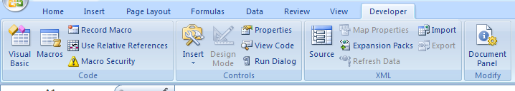

**.xlsx versus .xlsm**

An .xlsx file cannot store macros. Before recording your macro, use **Save As** to save the file as an xlsm file. After doing this, you might want to rename the .xlsx file (or delete it) to keep from submitting it by mistake.

**Recording the macro**

1. Copy your file, and work in the copy. If everything works fine, great. If not, delete the copy and start over, making another copy of the original to work in. Never work with macros unless you have a backup of the file somewhere. We say this because often what you do with a macro cannot be undone.
2. Identify the cells that you need to clear out. These will be all of the cells that serve as cell links for your form objects. Most of them should be on the *links* worksheet, but some may be on the *model* worksheet. You might want to give these cells a fill color before continuing.
3. Identify the two cells that will need to be populated with a value (see above, “Enter the value that represents…”), and make a note of what the value for each cell should be.
4. Double-check to make sure that you are not planning to touch any cells that contain formulas or functions!
5. Select the *data* worksheet, or any sheet other than the sheet(s) that you need to go to to clear cells. Do this so that the macro recorder can capture the click to the sheet that you want to start on.
6. On the Developer tab, in the Code group, click Record Macro.

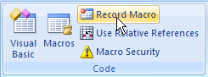

1. Assign a name, like *reset,* to the macro you are about to record. You might also want to add a description, like “Resets the application for new use.”

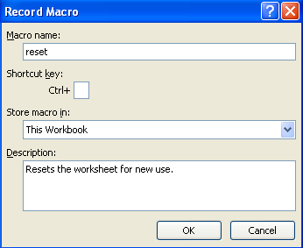

1. Click OK. From this point until you stop recording, *everything you do in Excel is being captured.*
2. Click the sheet tab for a sheet that needs to have cells cleared. Select those cells and hit the Delete key.
3. Enter the appropriate values in the two cell links that need to be populated with values (to set the application to 35mm B&W).
4. Stop recording: On the Developer tab, in the Code group, click Stop Recording.

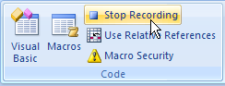

**Testing the macro**

Pretend that you are taking a customer order. Fill out the film type, color, exposures/files, etc.

Test to see whether the macro works by returning to the Developer tab. In the Code group, click Macros.

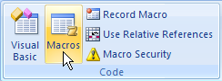

Select your macro from the list and click Run. The macro should return the application to the default status specified in the instructions.

If your macro works but you see screen flickering as it runs, that’s OK. (If you’re interested, there’s a line of code that you can add to turn screen updating off [and then, crucially, back on!]. Ask one of us to show you how to add those lines of code—but don’t worry about it for the file that you submit.)

If your macro doesn’t work, close the file, delete the file, and make a copy of the backup file to try again in. Remember that your file must have an .xlsm extension.

**Attaching the macro to a button or image**

Finally, to make running you macro more user-friendly, attach it to a button.

On the Developer tab, in the Controls group, click Insert. Locate the button listed under Form Controls and click it once.

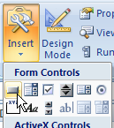

Draw a button on the *model* worksheet.

You should be prompted to assign a macro to this button. Select your macro from the list and click OK.

Once you click away from the button, it functions as a button. You can always right-click the button if you need to resize it or change the text on it.

If you prefer, you can attach your macro to an image. Insert an image on the *model* worksheet, right-click the image and choose **Assign macro**.